APPENDICES

1. Resource Person’s

**Engr. Ronaldo A. Liveta, CESE Meka Ella Pesario**

OIC Director Scholar of Tulong Dunog

CHED Region XII

**Dr. Nelia A. Alibin Ms. Chola Marie B. Iglesias**Regional Director IV Capstone Adviser

CHED Region XII

**Eden Stephanie B. Bolido,**

Regional Coordinator

CHED Region XII

**Stevean Renz Sabasaje**

Aklat-Edukar General Santos City

**Chola Marie B. Iglesias**

Capstone Project Adviser

**Anthony Silang**

STI GenSan Scholarship Admin

**Jefsey Enhog**

Scholar of Edukar

1. Relevant Source Code
2. Evaluation Tool or Test Document

Name:___________________________________________________ Date:________________

**Check the corresponding response rating based on the given criteria.**

**USER TYPE:**

Student Organization

Rating: 1 as the lowest, 5 as the highest.

1. **Design of the system and the modules (User Interface)**

|  |  |  |  |  |  |
| --- | --- | --- | --- | --- | --- |
|  | **1** | **2** | **3** | **4** | **5** |
| 1. The overall design of the website. |  |  |  |  |  |
| 2. The screen layout is consistent or responsive |  |  |  |  |  |
| 3. The system design is user-friendly. |  |  |  |  |  |
| 4. Labels are understandable. |  |  |  |  |  |
| 5. Can easily navigate modules and features. |  |  |  |  |  |
| 6.The font size is readable. |  |  |  |  |  |
| 7. The modules and forms of the system are well organized. |  |  |  |  |  |

1. **Usability and Functionality (Student Users)**

|  |  |  |  |  |  |
| --- | --- | --- | --- | --- | --- |
|  | **1** | **2** | **3** | **4** | **5** |
| 1. The overview of scholarship programs is accessible in the home page. |  |  |  |  |  |
| 2. The login process responds quickly. |  |  |  |  |  |
| 3. Scholarship program criteria is understandable. |  |  |  |  |  |
| 4. The basic information on profile is accurate. |  |  |  |  |  |
| 5. Can easily apply on a specific scholarship program. |  |  |  |  |  |
| 6. Filters in searching for scholarship programs are usable. |  |  |  |  |  |
| 7. Transactions are completed successfully from beginning to end. |  |  |  |  |  |
| In applying, attachments are accessible to any file type. |  |  |  |  |  |

1. **Usability and Functionality (Organization Users)**

|  |  |  |  |  |  |
| --- | --- | --- | --- | --- | --- |
|  | **1** | **2** | **3** | **4** | **5** |
| 1. The overview of scholarship programs is accessible on the landing page. |  |  |  |  |  |
| 2. The login process to the website is easy. |  |  |  |  |  |
| 3. Scholarship program criteria are easy to view. |  |  |  |  |  |
| 4. The basic information on the profile is accurate. |  |  |  |  |  |
| 5. Can easily apply to a specific scholarship program. |  |  |  |  |  |
| 6. Filters in searching for scholarship programs are usable. |  |  |  |  |  |
| 7. Transactions are completed successfully from beginning to end. |  |  |  |  |  |
| 8. In applying, attachments are accessible to any file type. |  |  |  |  |  |

1. **Appropriateness**

|  |  |  |  |  |  |
| --- | --- | --- | --- | --- | --- |
|  | **1** | **2** | **3** | **4** | **5** |
| 1. User-friendly/ease of use. |  |  |  |  |  |
| 2. Suited to the abilities and skills of the user. |  |  |  |  |  |
| 3. The system caters to the needs of the users. |  |  |  |  |  |
| 4. The system provides all the modules necessary. |  |  |  |  |  |
| 5. It is easy to apply for scholarships. |  |  |  |  |  |
| 6. It is easy to add scholarships and access applicant information. |  |  |  |  |  |

1. **Suggestions and/or Recommendations**

___________________________________________

Name and Signature

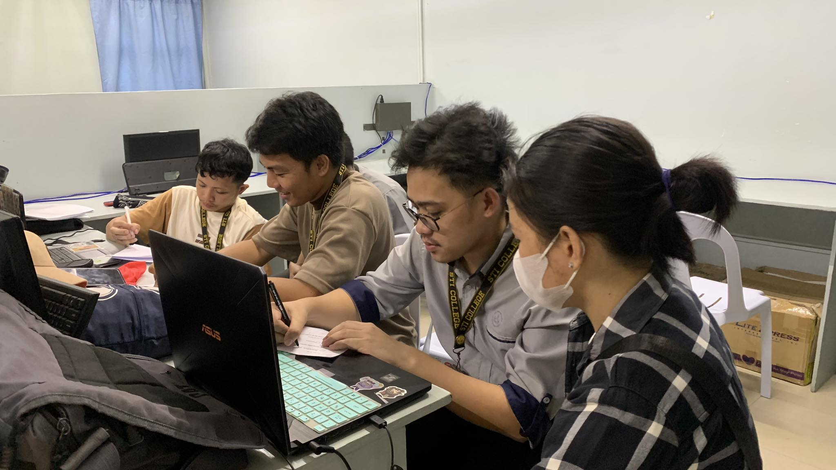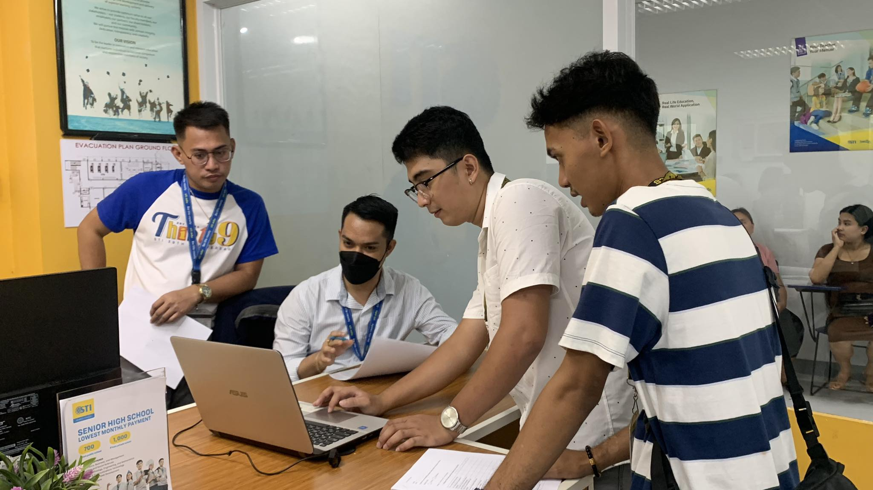

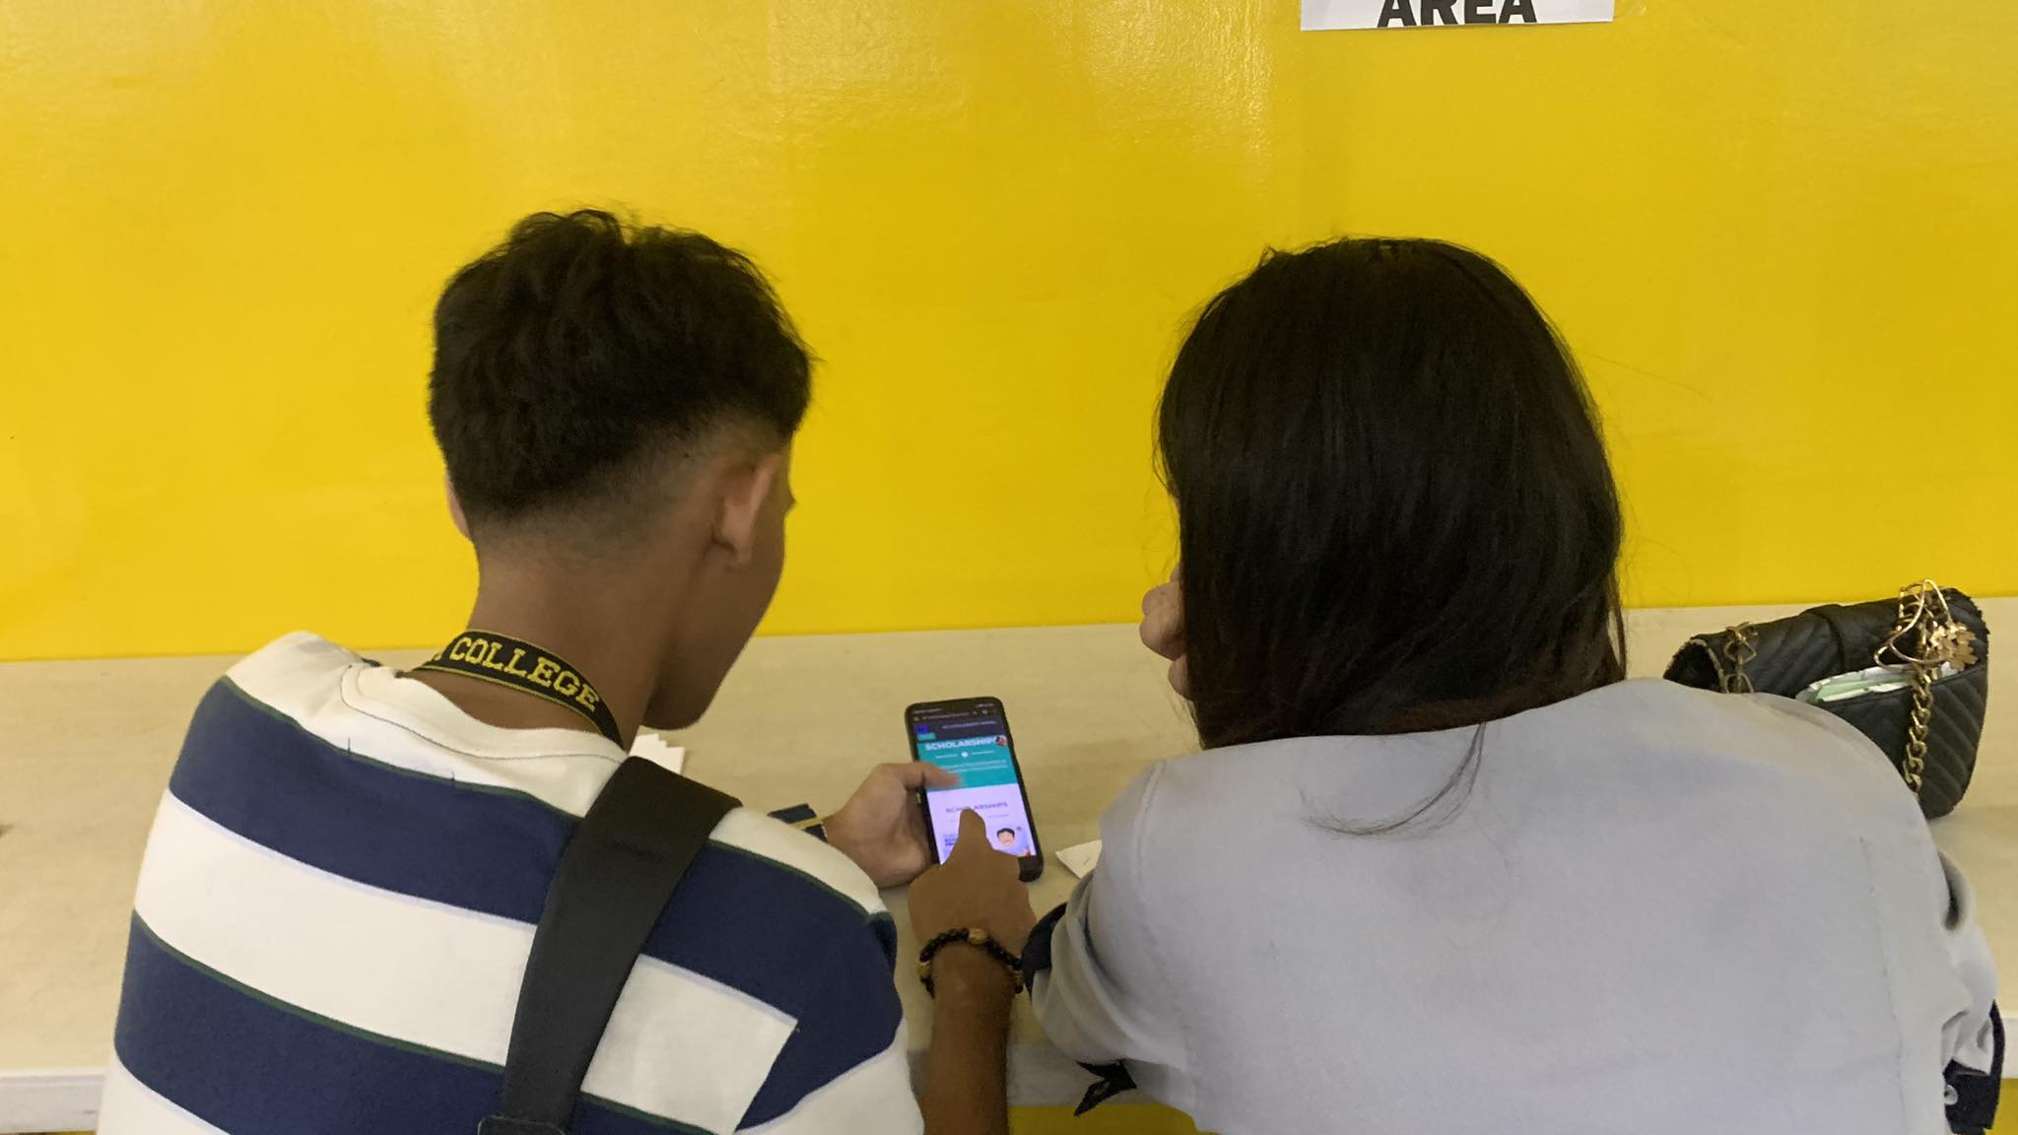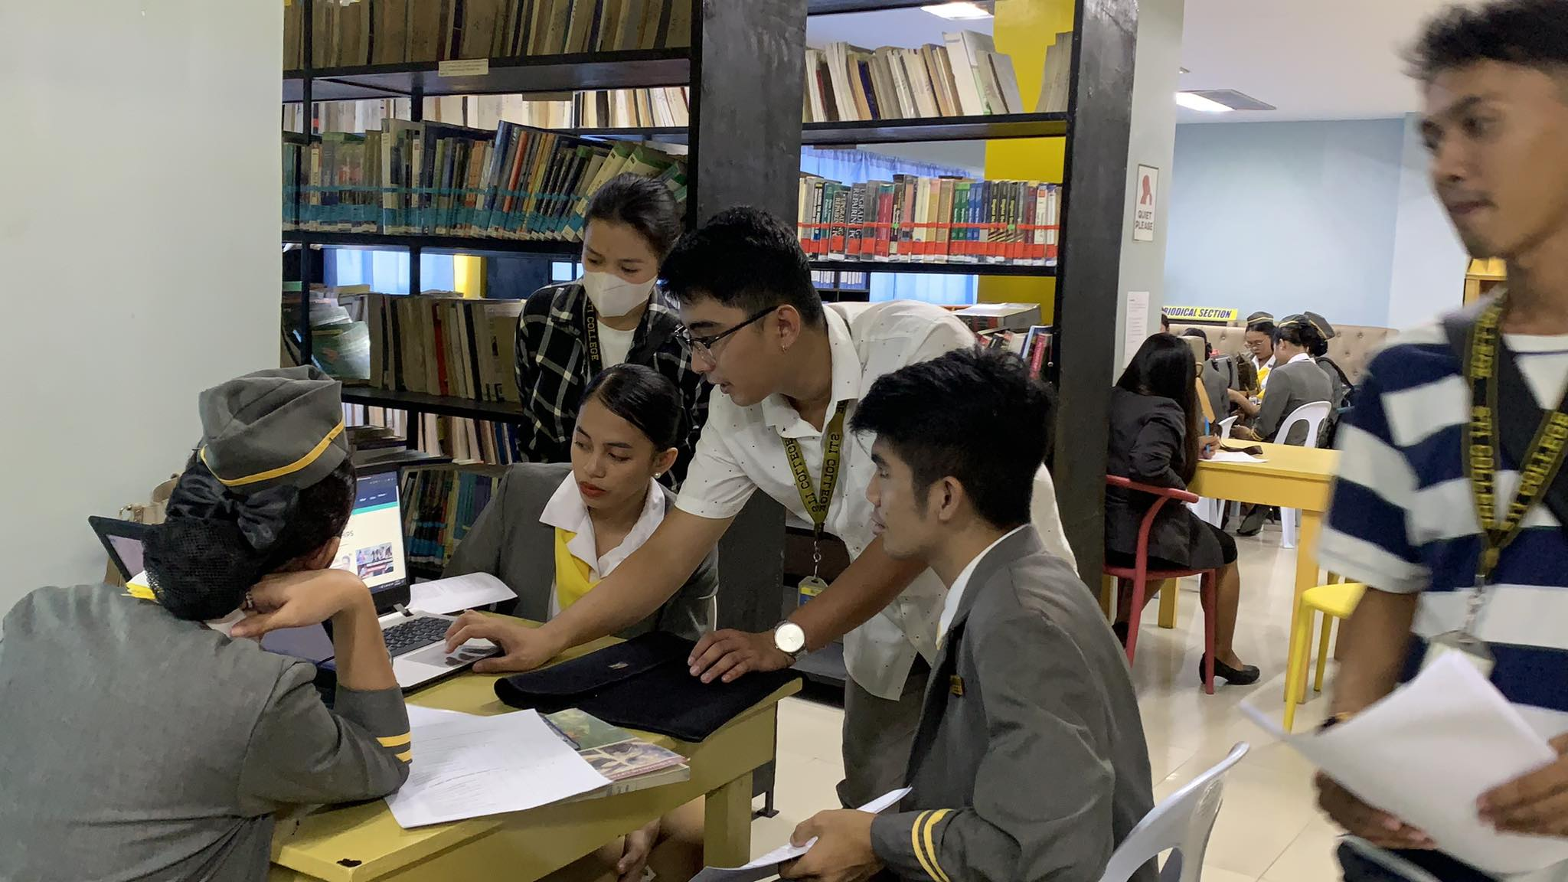

1. Sample Input/Output/Reports

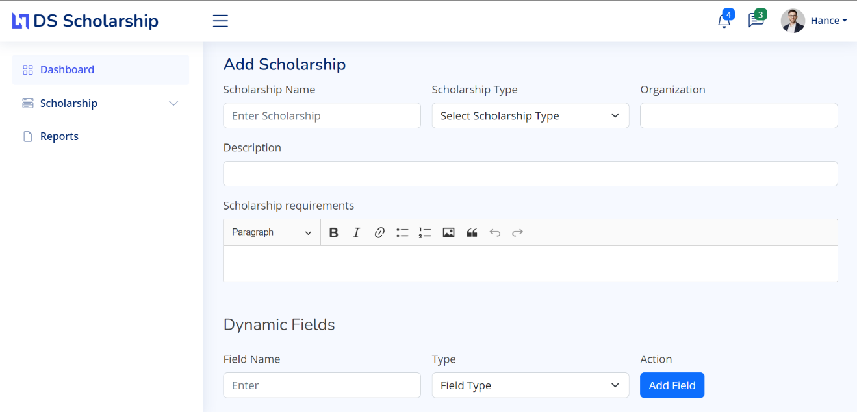Input Scholarship Program (organization)

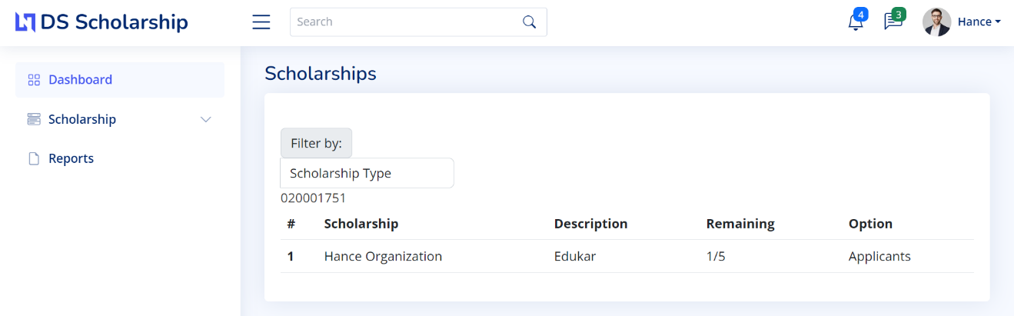Output:

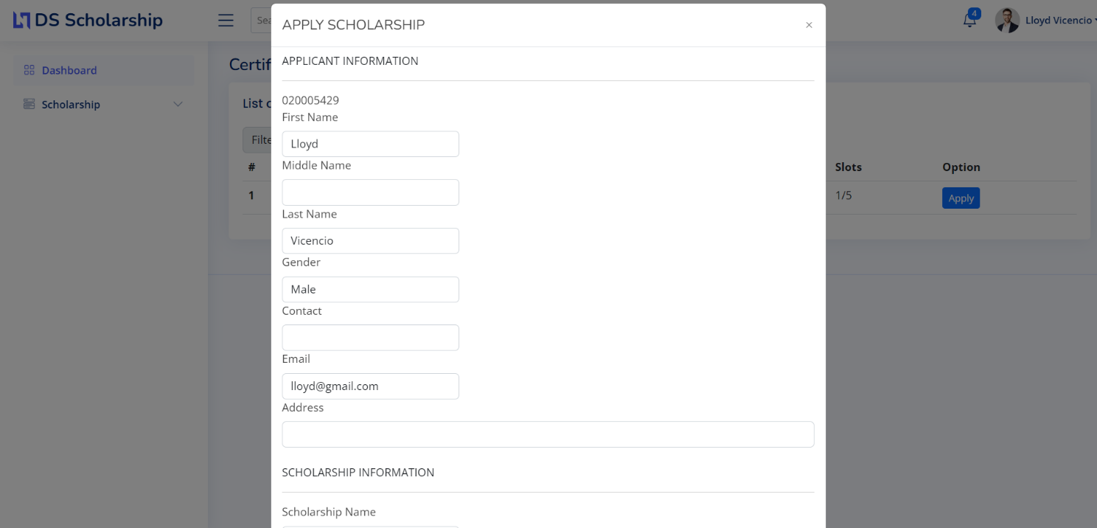Input applicant information (student)

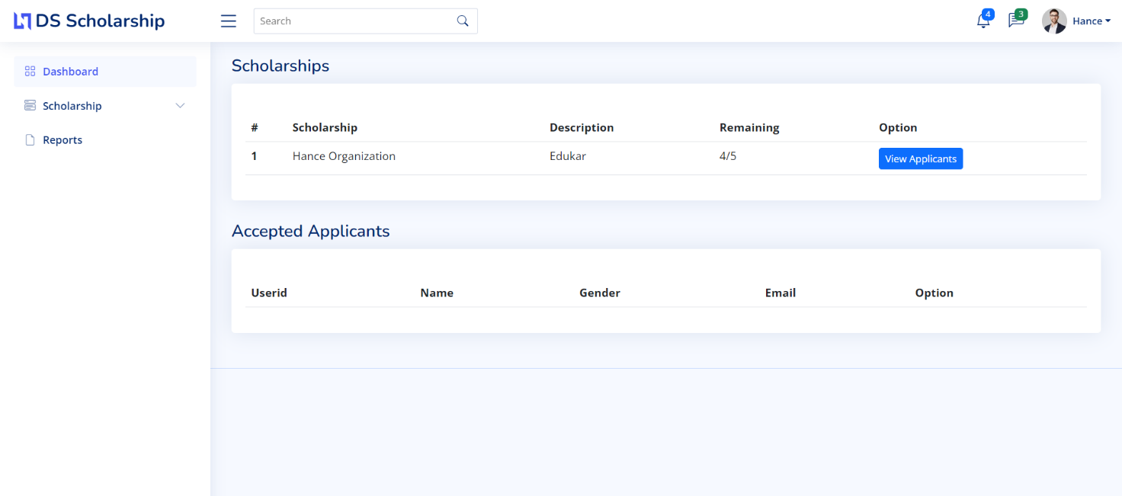Output:

1. User’s Guide
2. Diagrams

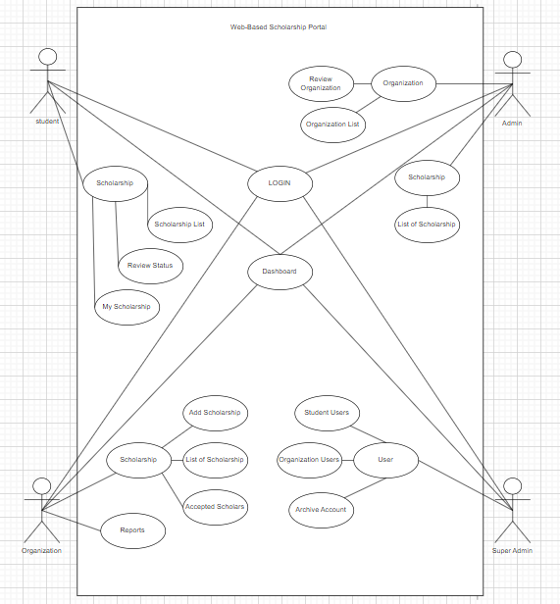Use-Case Diagram

CFD – Context Flow Diagram (Automatic)

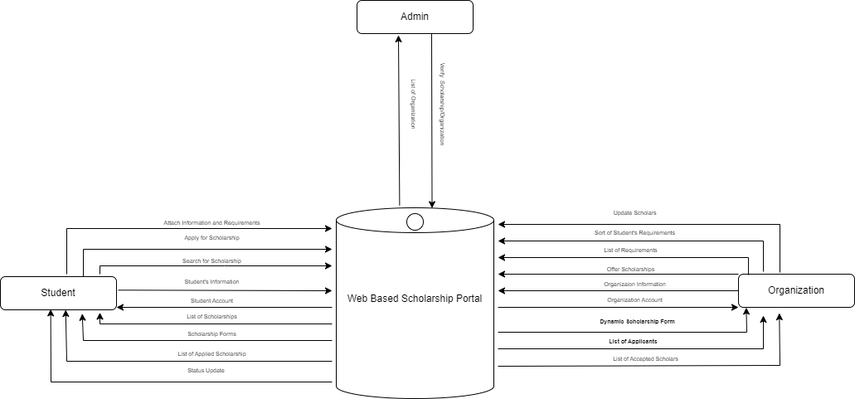

CFD - Context Flow Diagram (Manual)

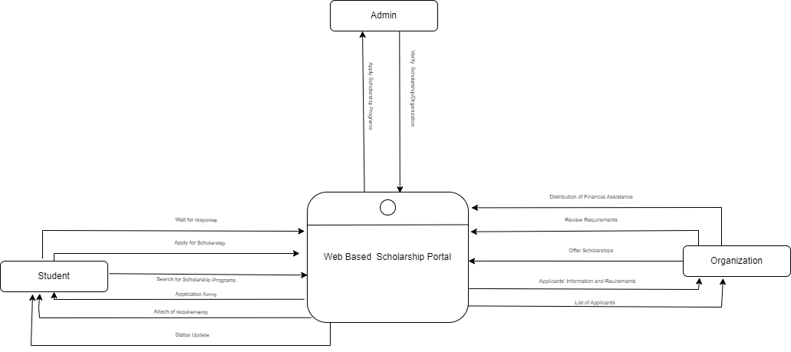

Diagram 0

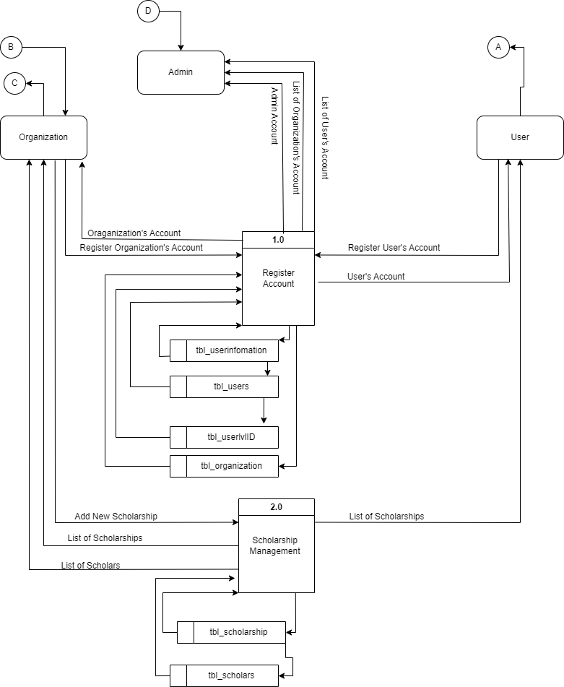

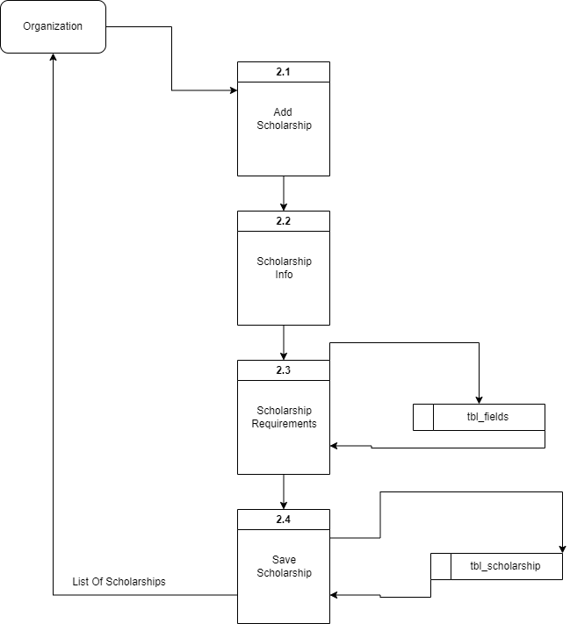

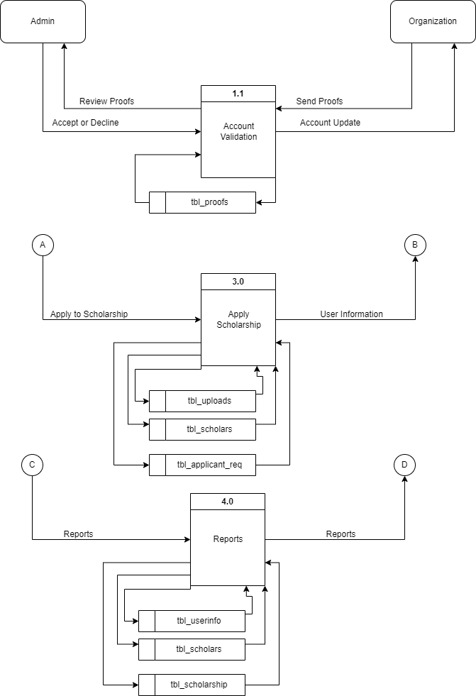

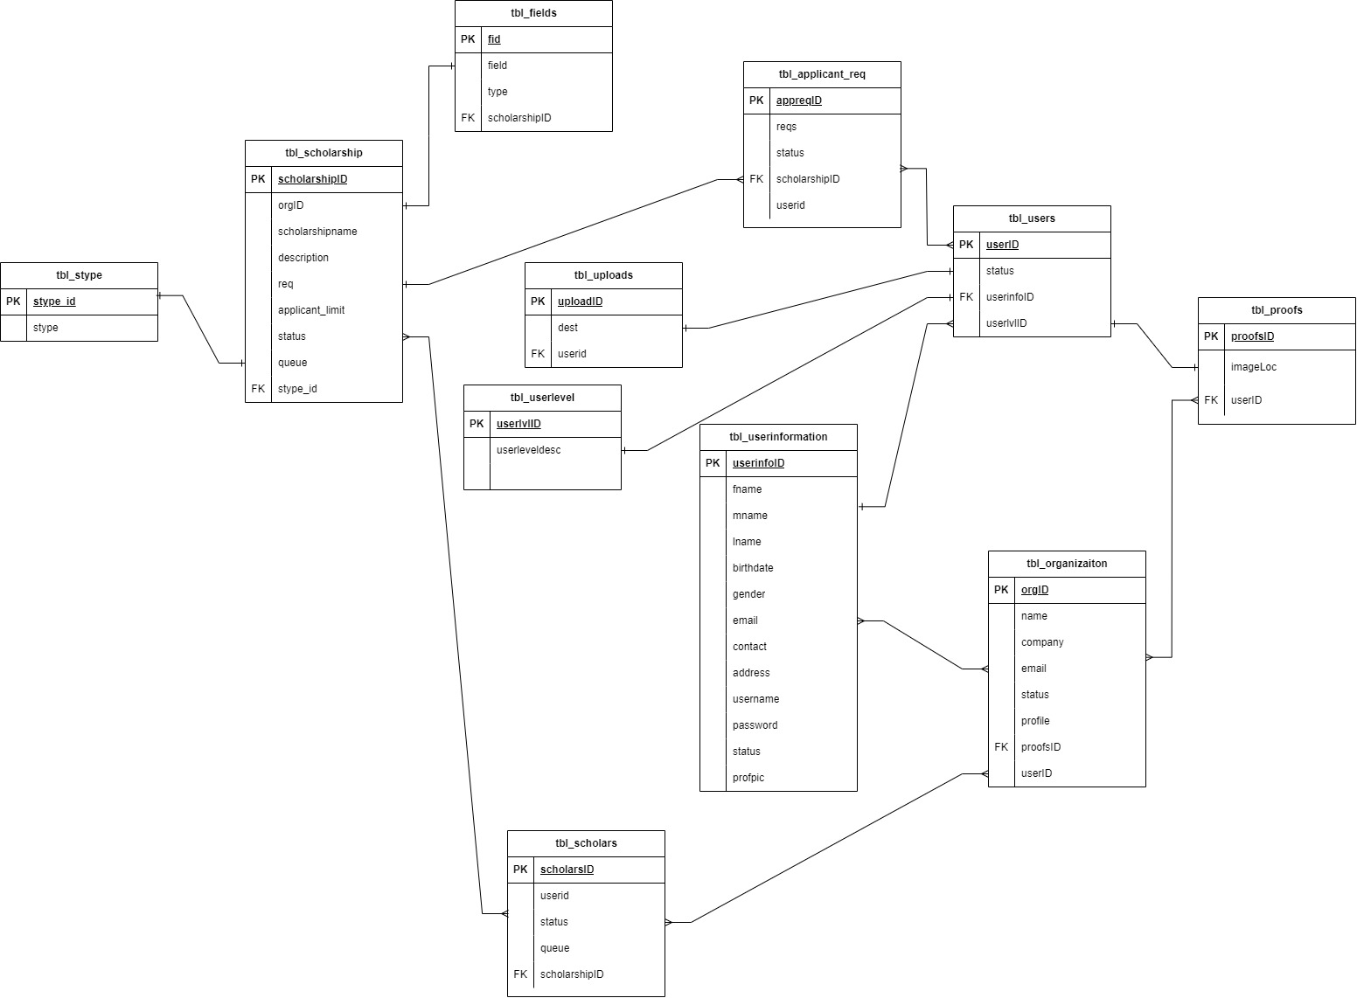ERD

1. Copy of Revision List Form (Capstone 1)

**GROUP 1**

Scholarship Portal

* Scholarship Management
* Create a form for each scholarship type (Merit-based, Skills-based, Needs-based, Context-based)-(dev)
* Create scholarship with details(org)
* Application Process (applicant)
* List of scholarships (landing page, applicant)
* Filter by type, program level, grant, application deadline
* List of applicants
* per org
  + filter by merit, skills, needs-eligibility, context.
  + update status
* all (admin)

Notification for each status transaction (sys)

* Sponsor/Organization Management
* CRUD org/sponsor (admin)
* Retention
* Reports

1. Certificates of Statistician and Grammarian

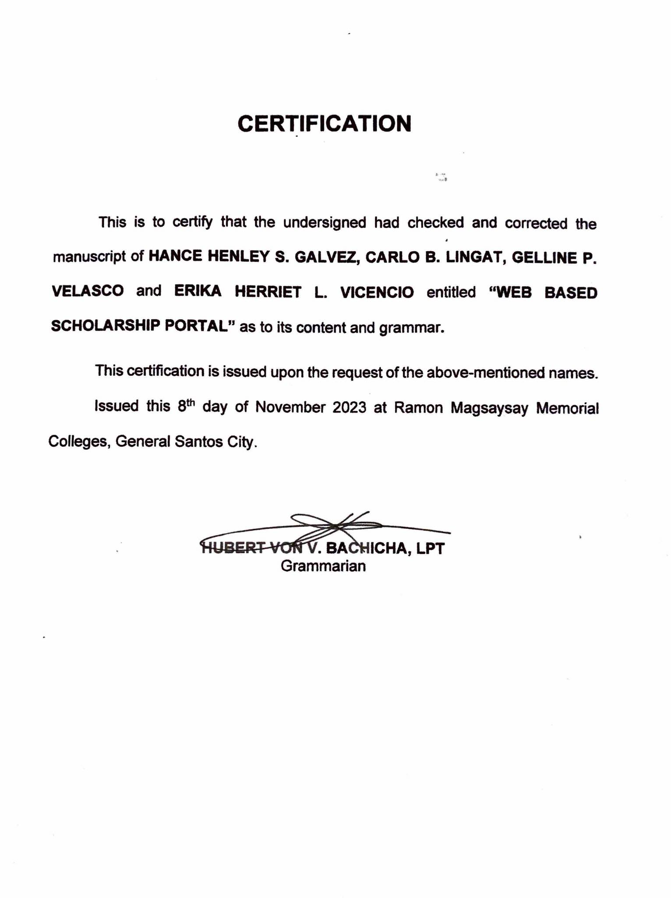

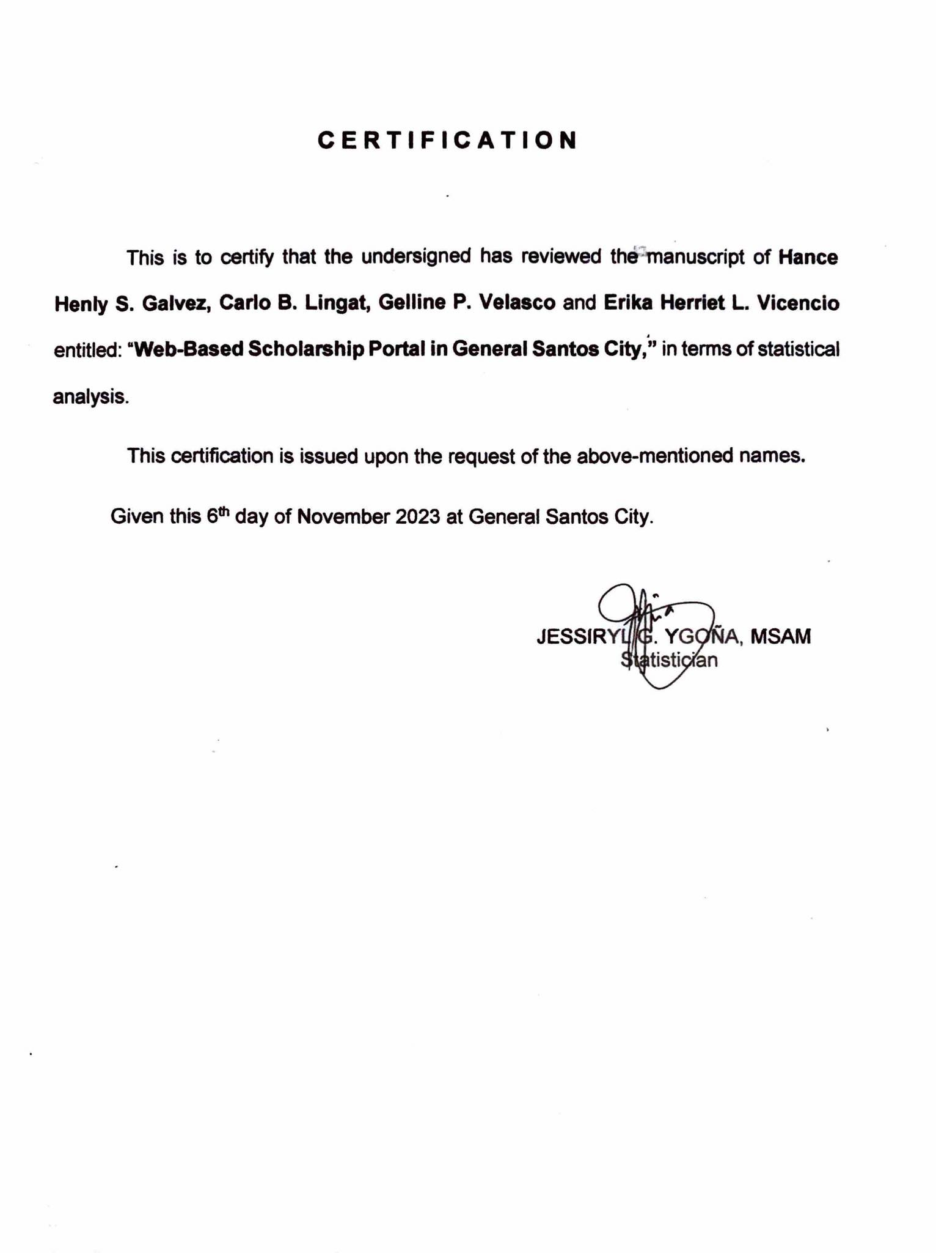

1. Data Gathering Tools and Responses

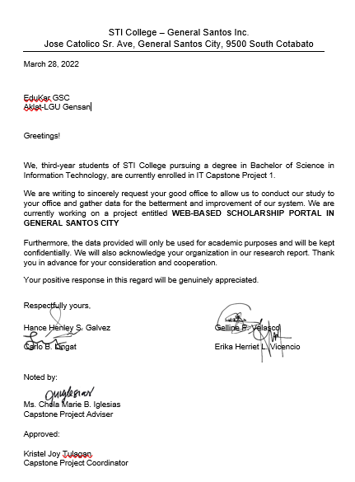

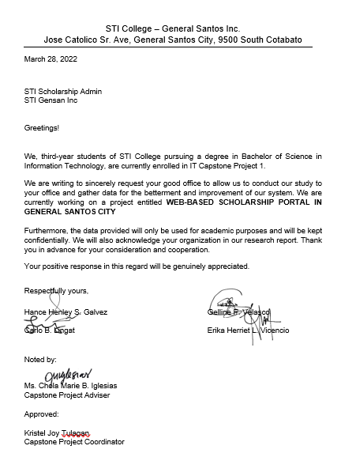

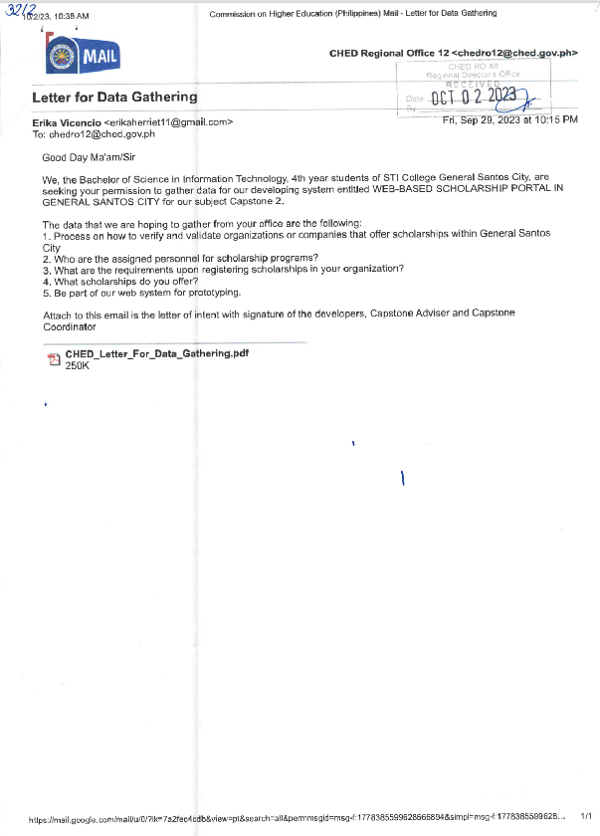

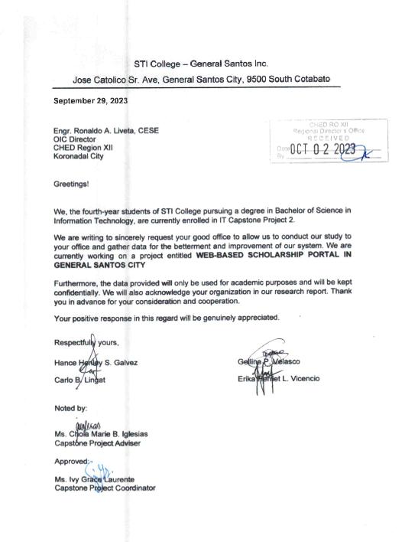

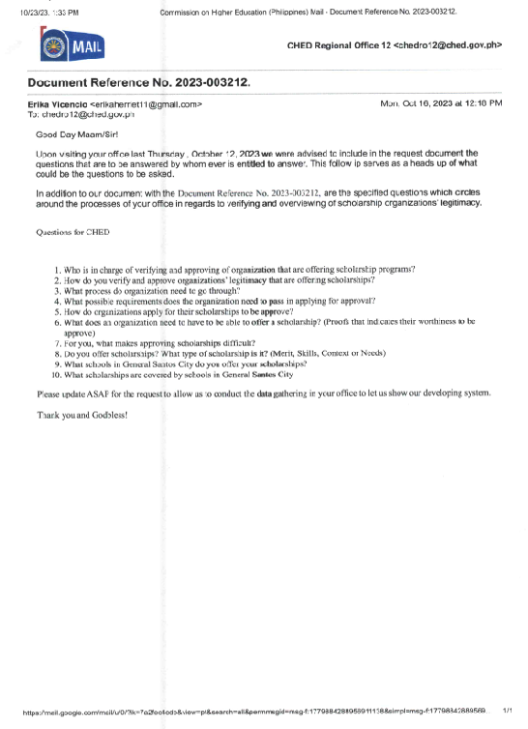

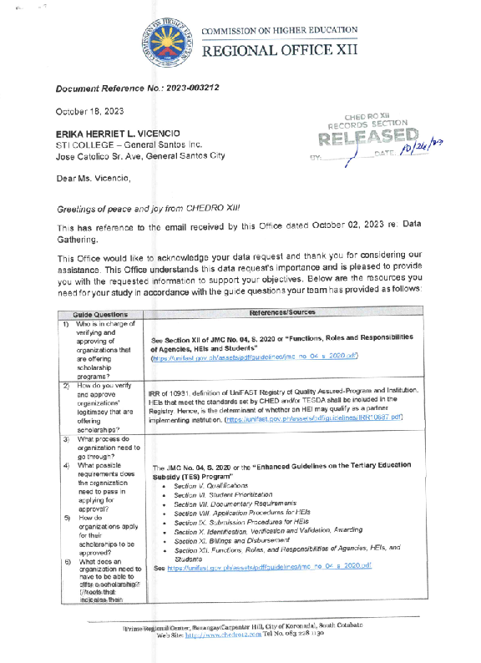

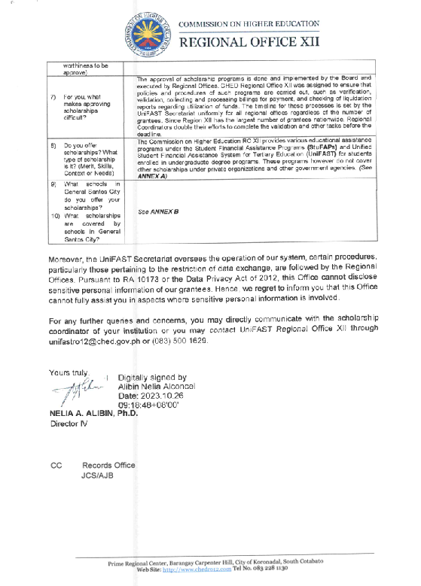

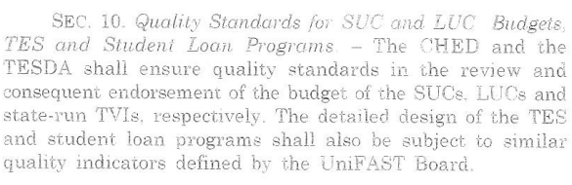R.A. 10931 or Universal Access to Quality Tertiary Education Act

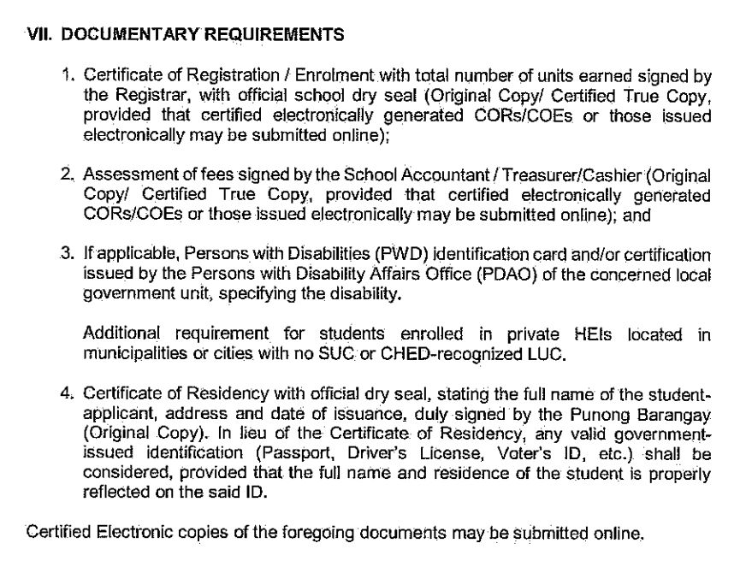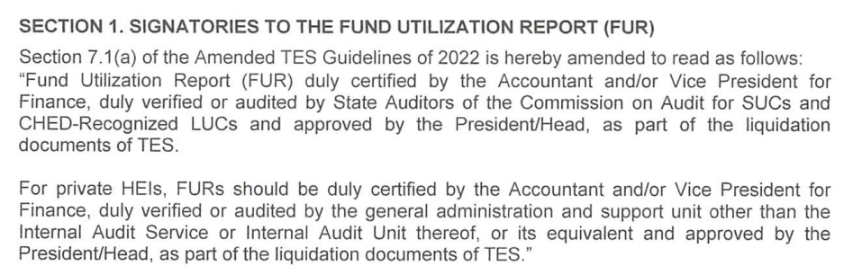  
MC. No. 4, Series of 2023: Further Amendments of Amended Tertiary Subsidy Guidelines of 2022

JMC No. 4 2020 Enhanced Guidelines on Tertiary Education Subsidy (TES) Program

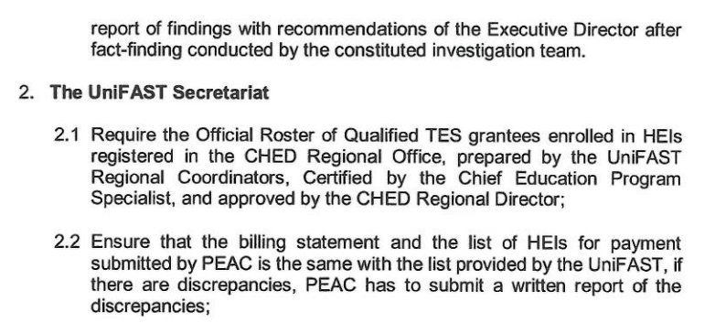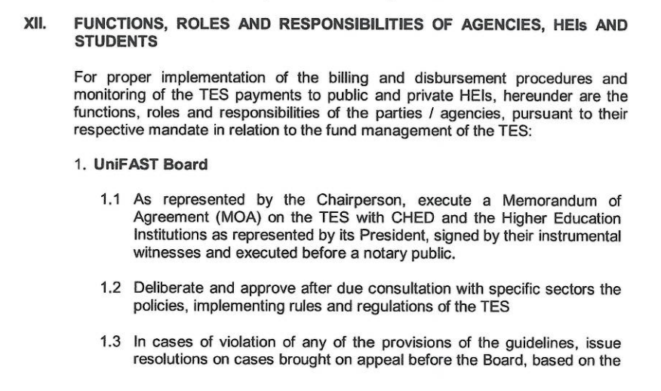

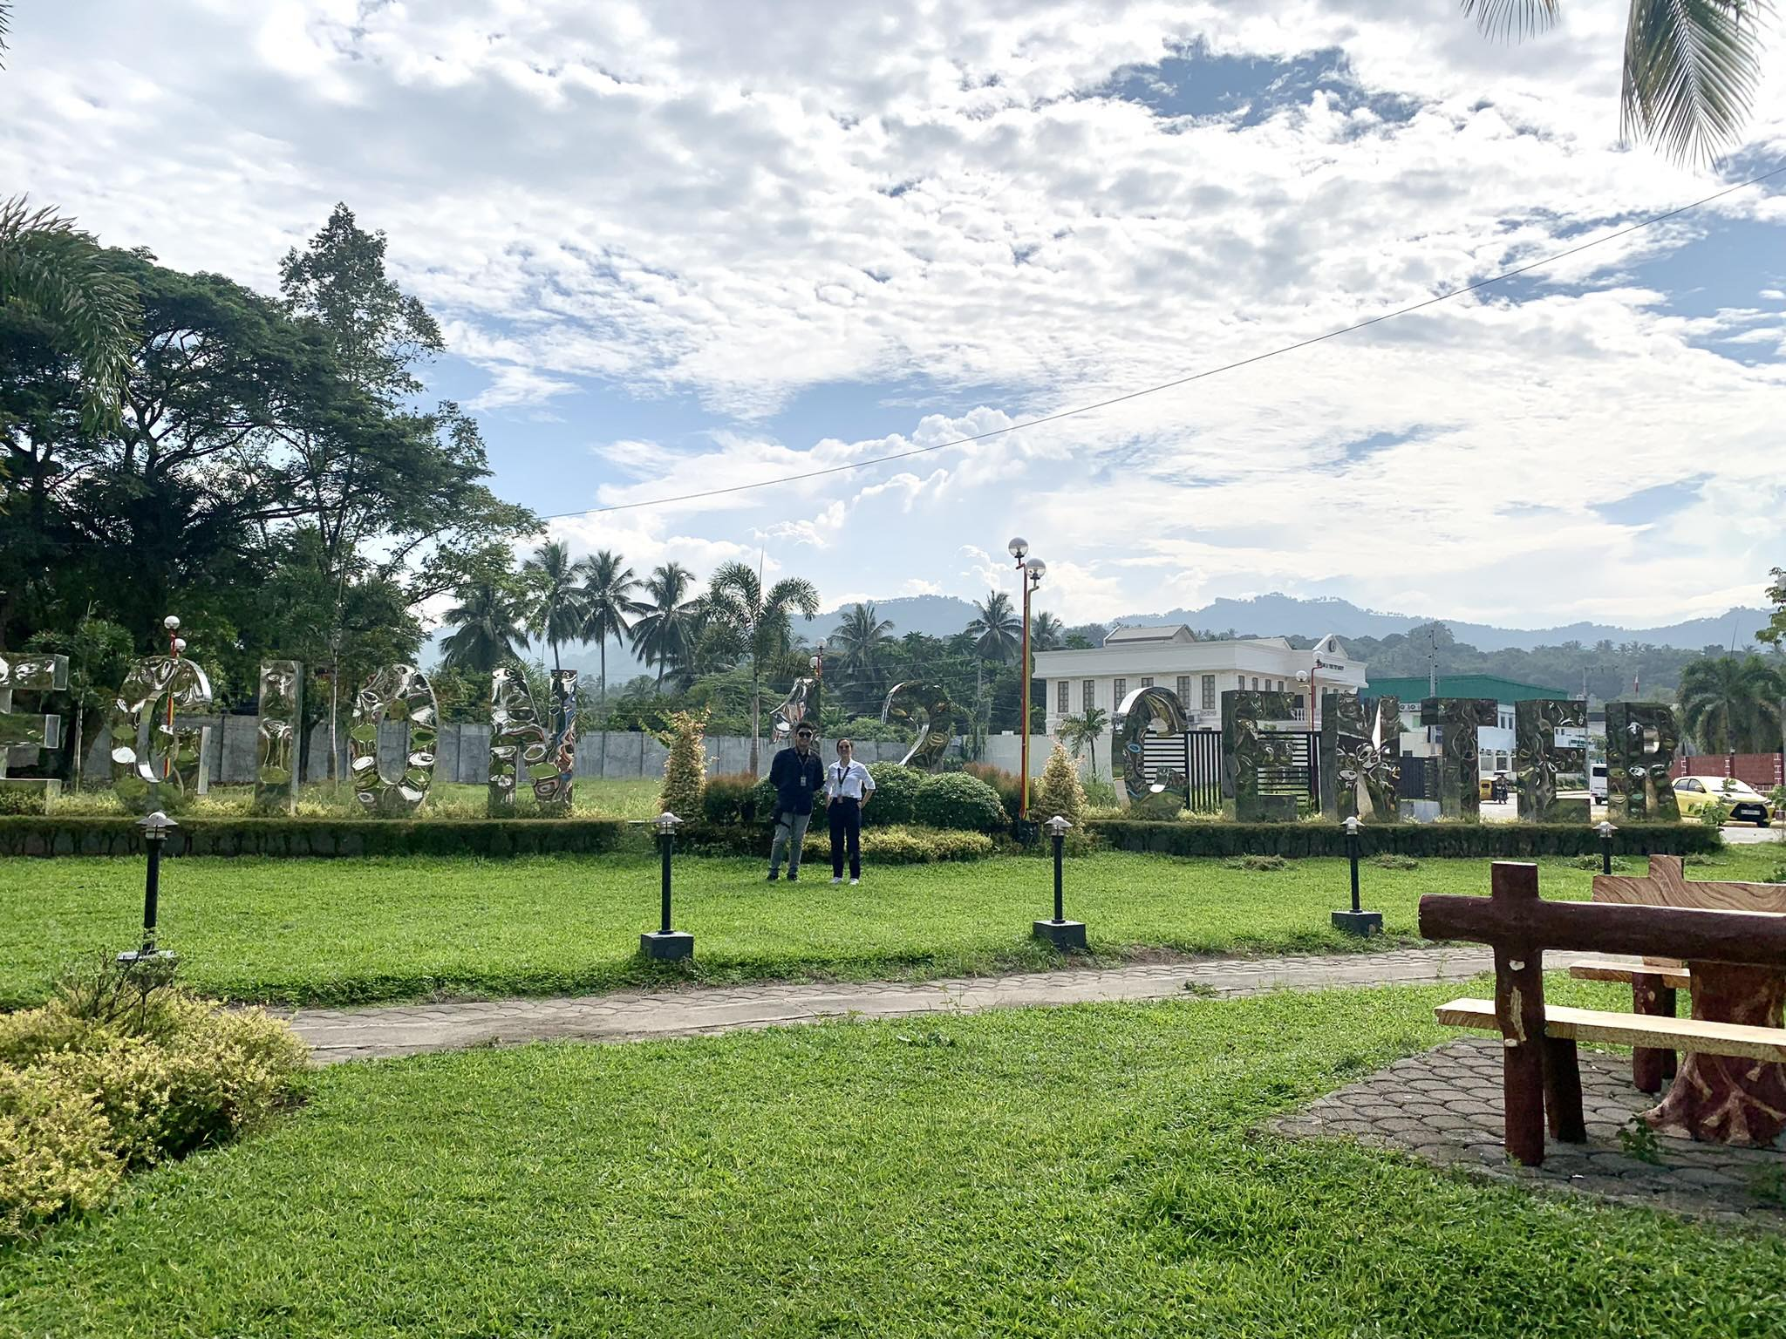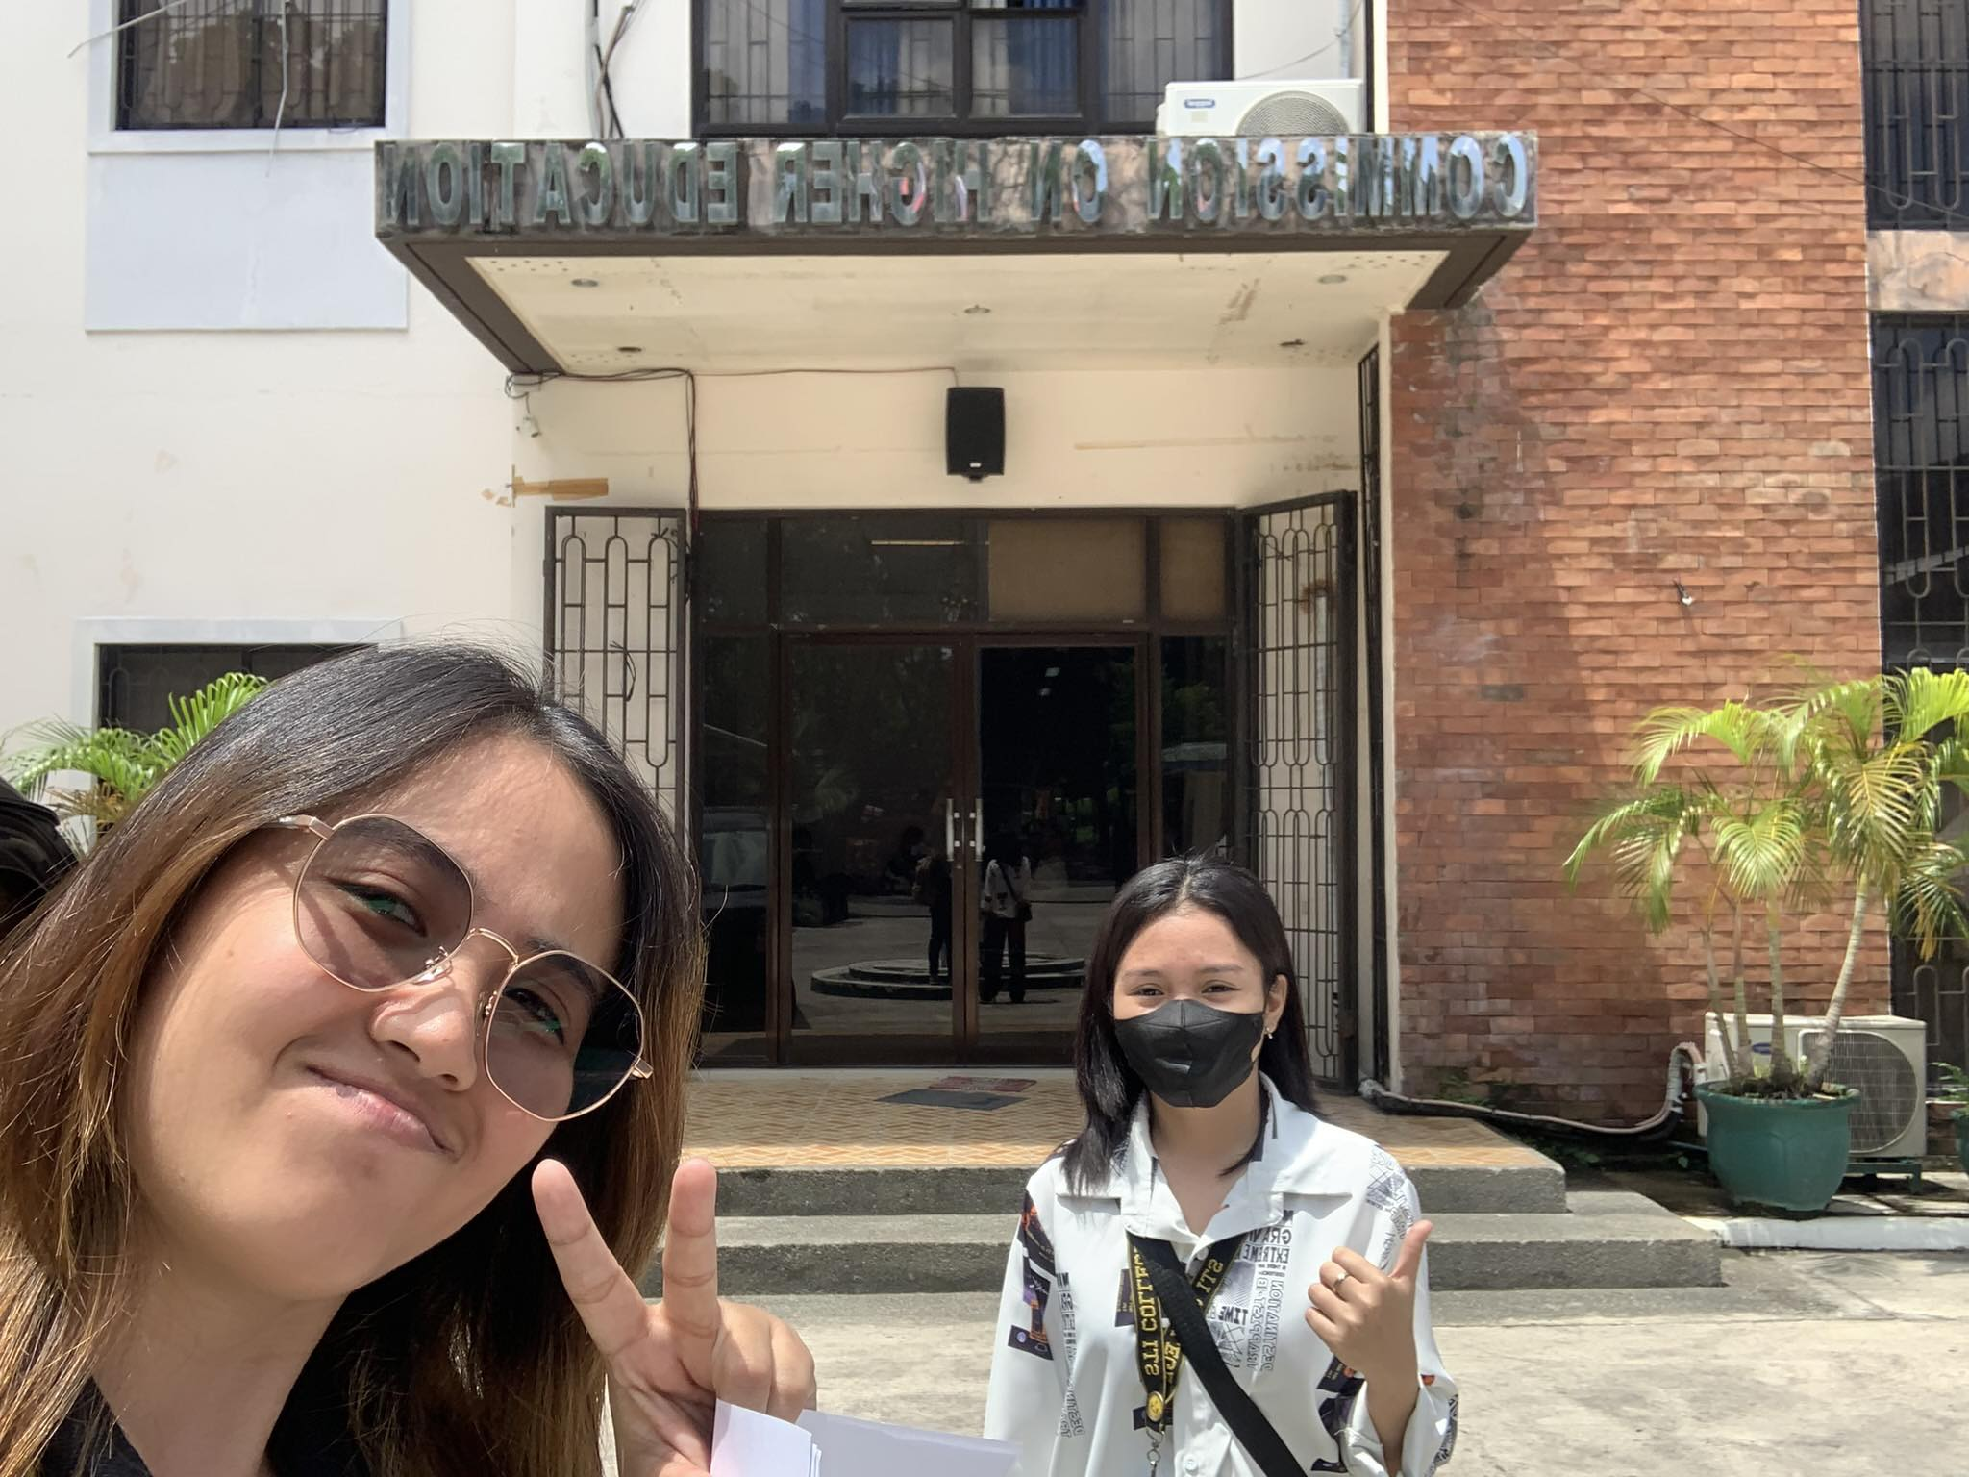

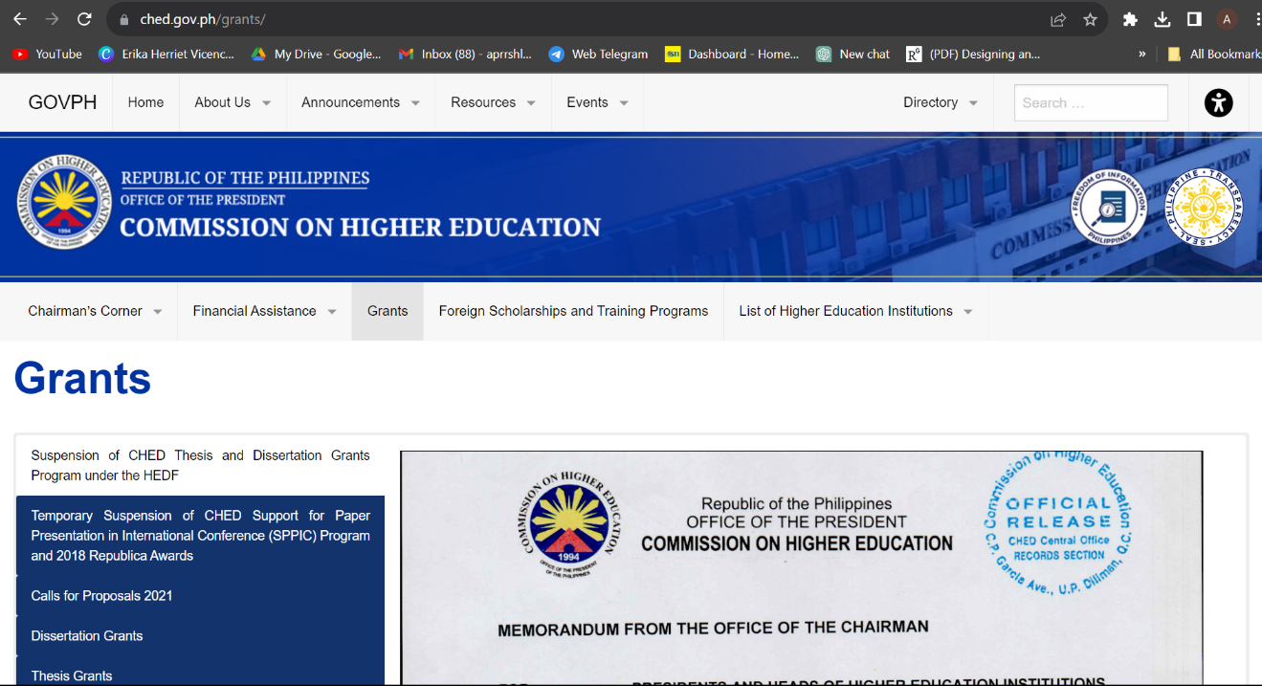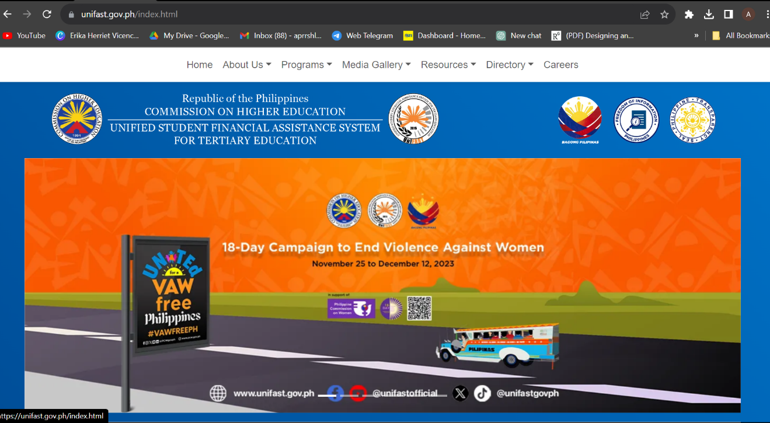

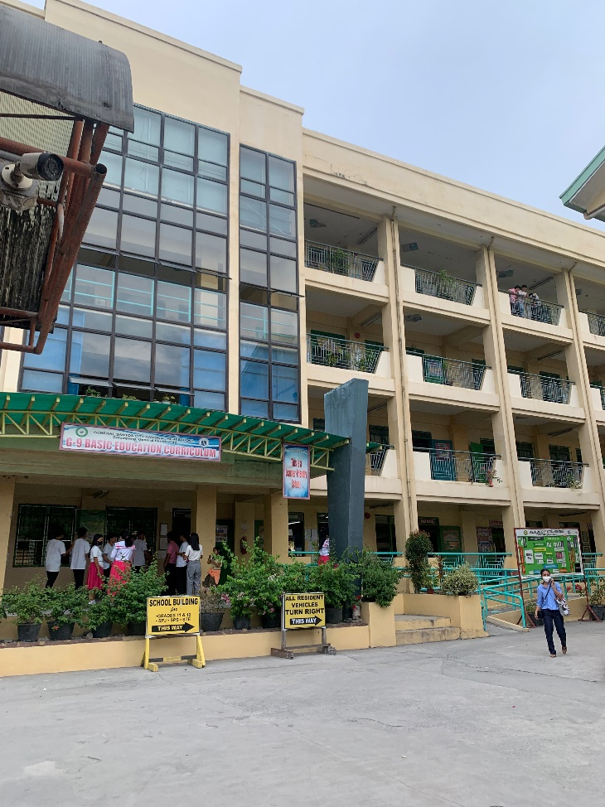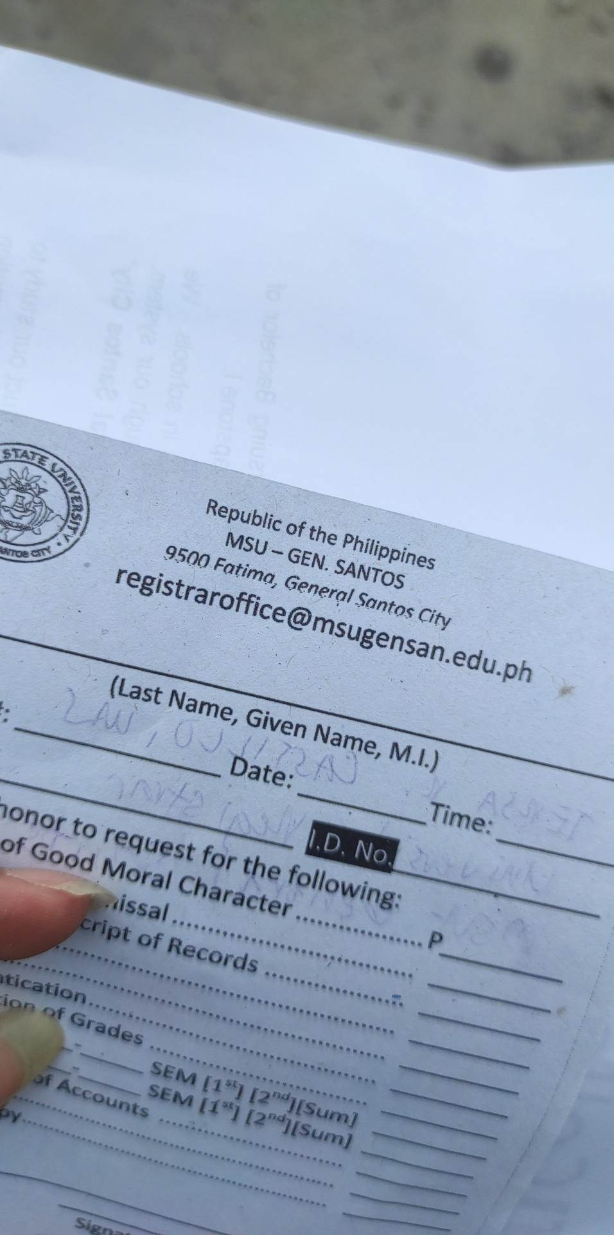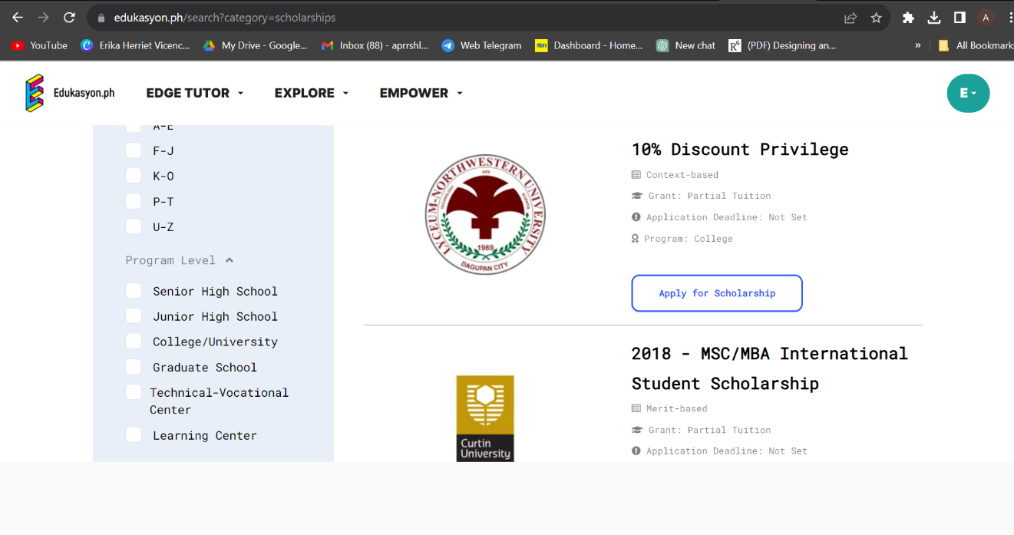

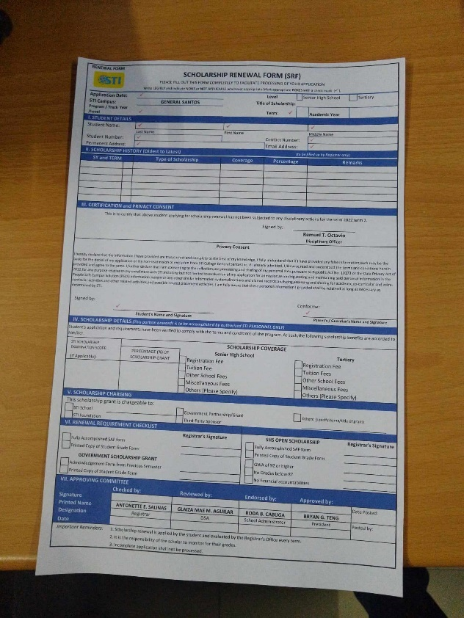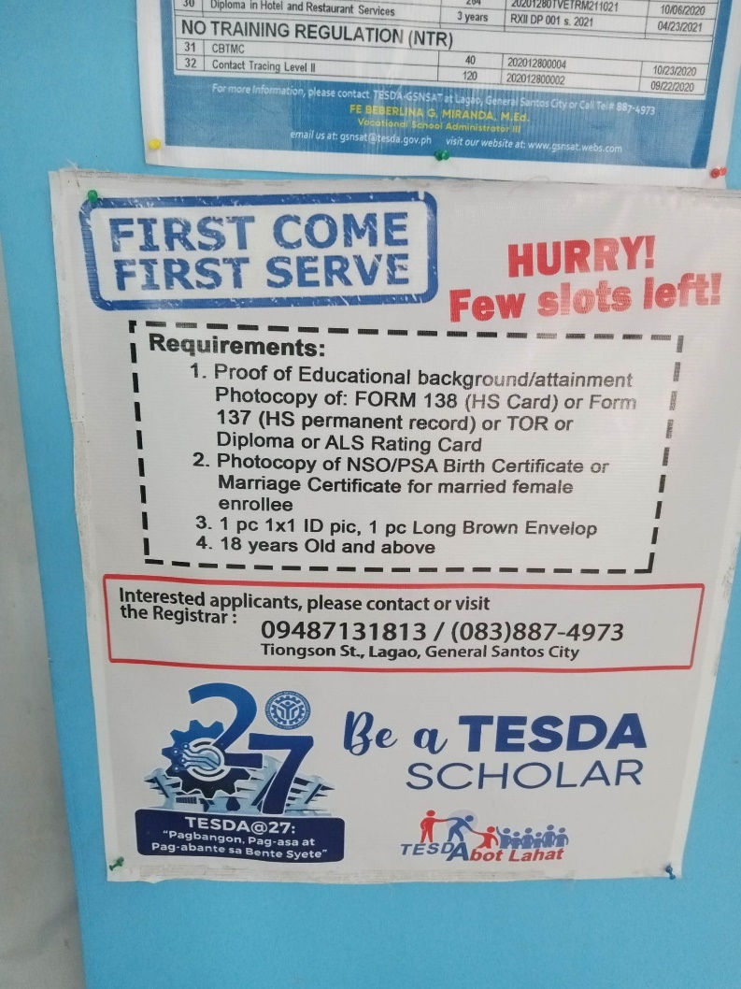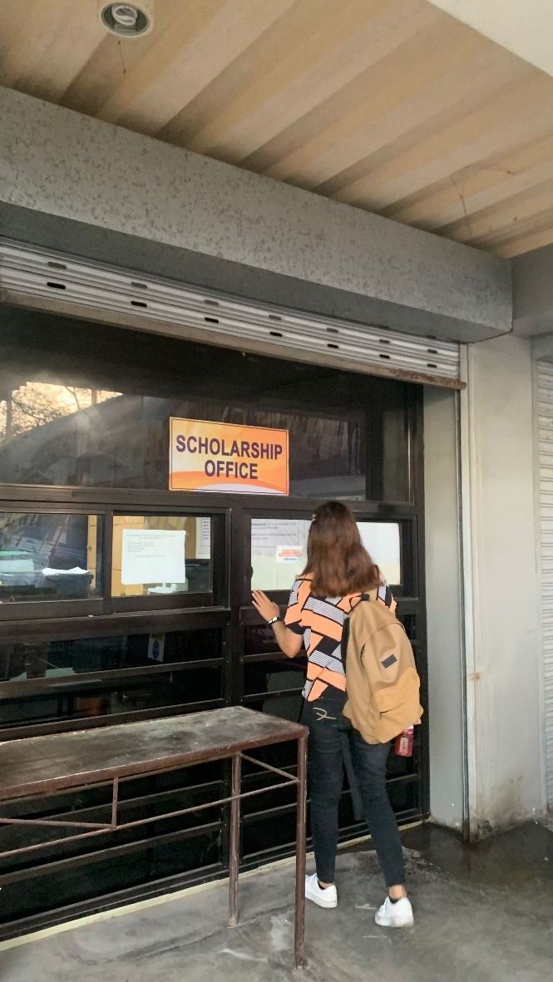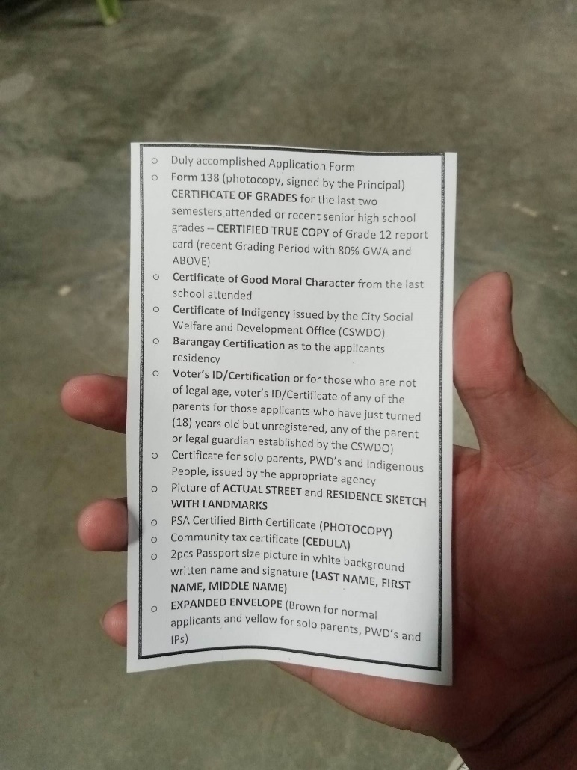

1. Accomplishment and Consultation Forms

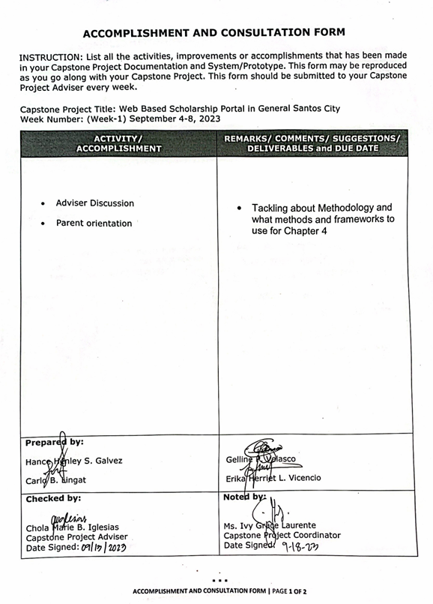

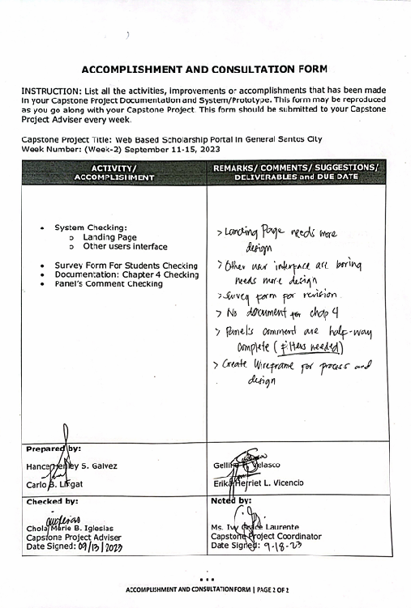

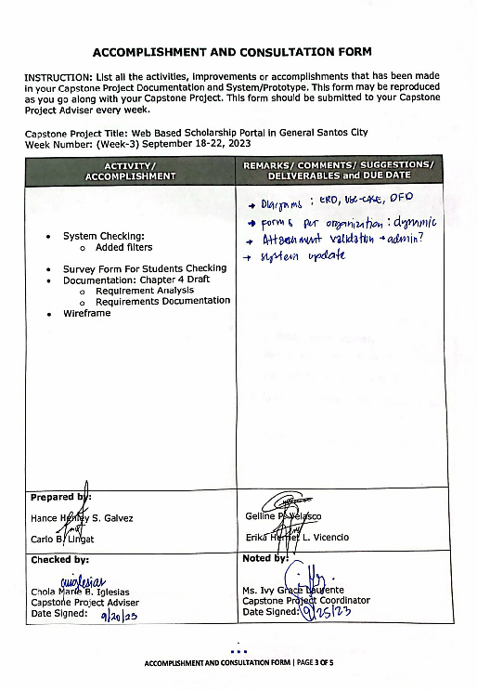

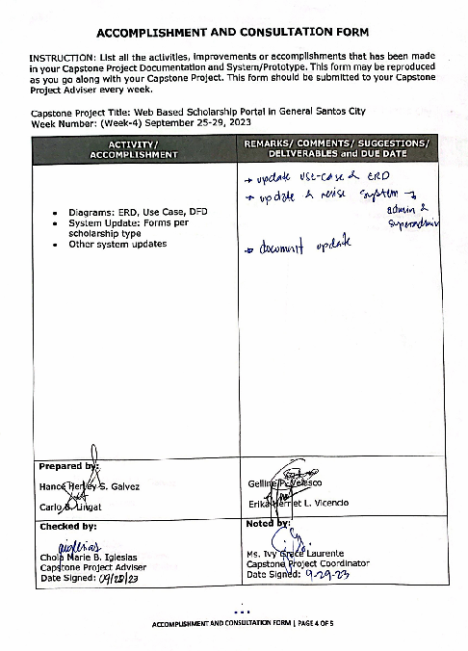

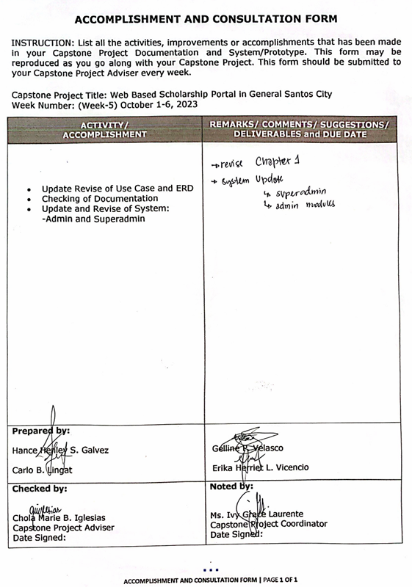

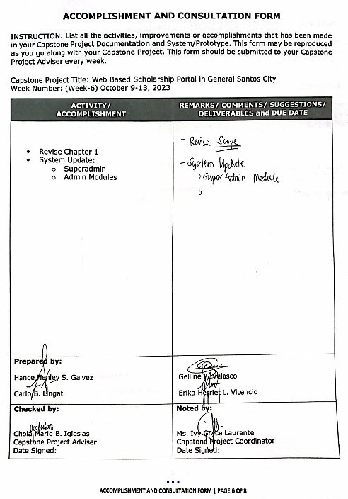

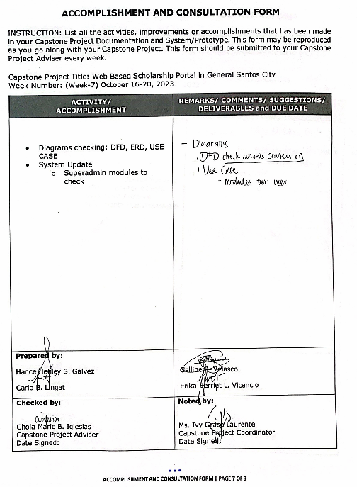

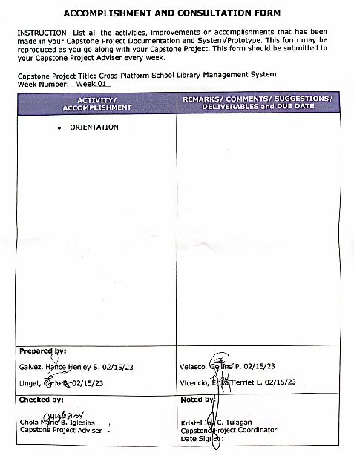

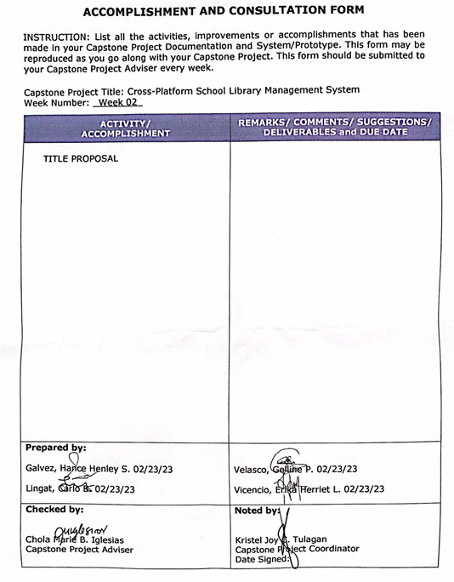

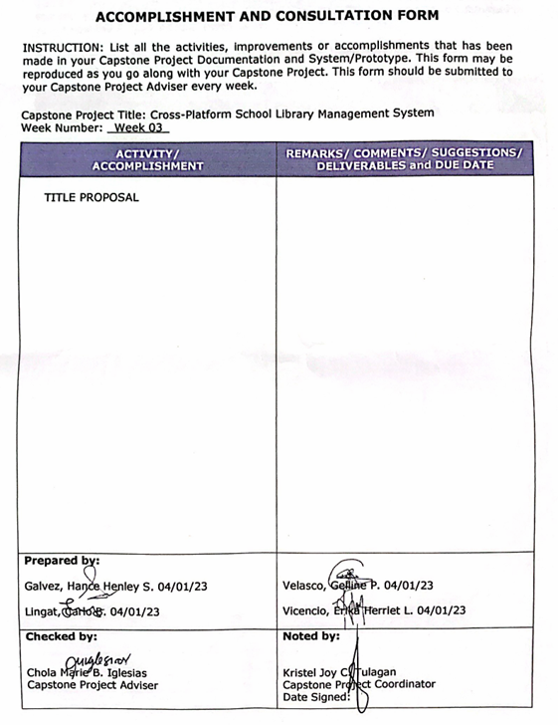

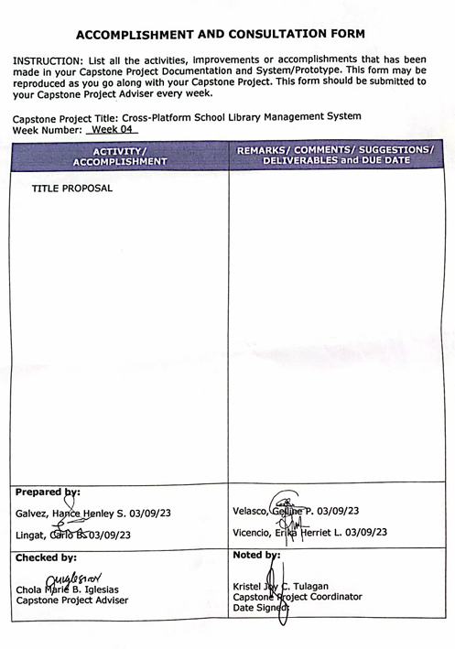

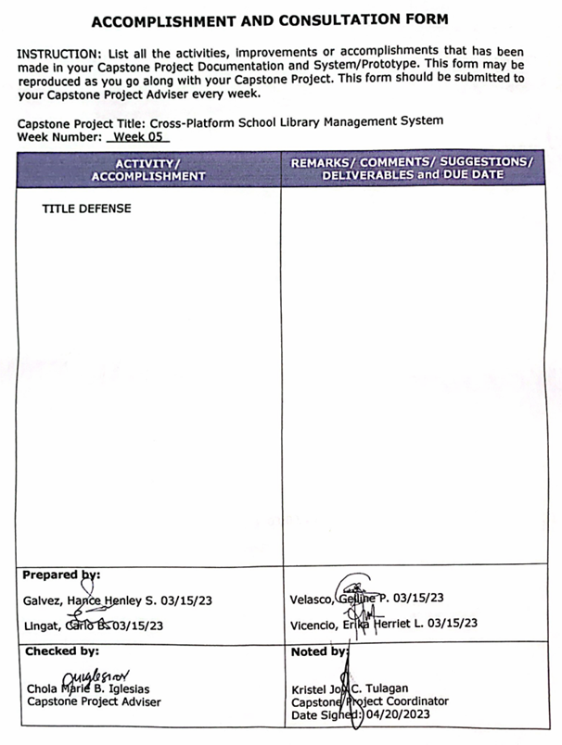

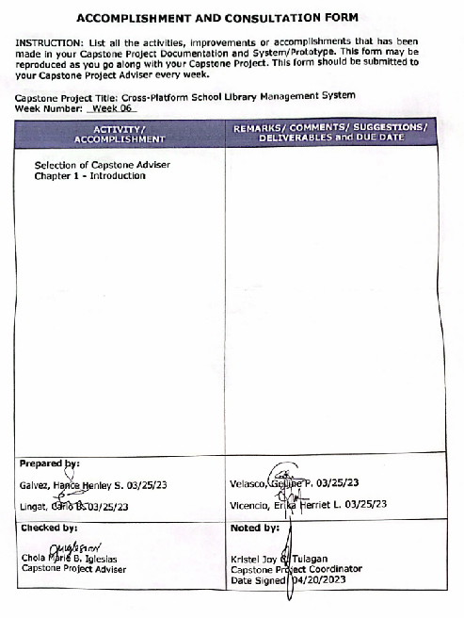

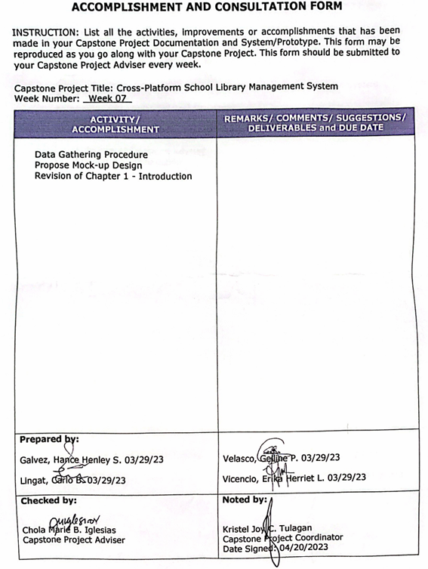

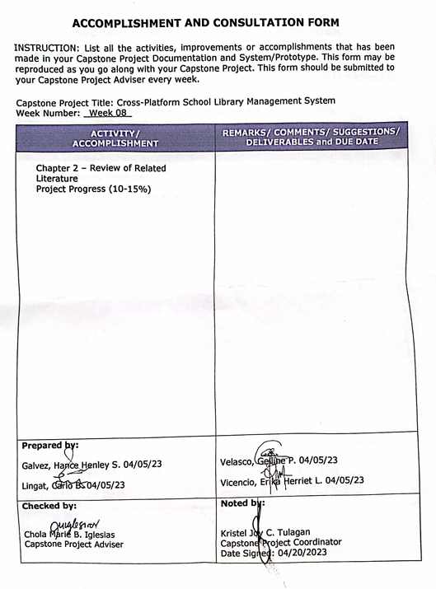

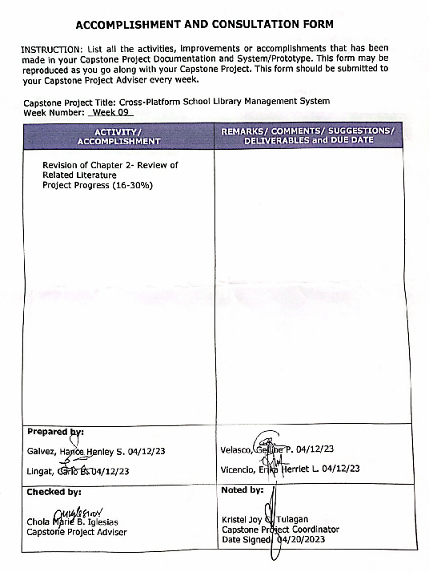

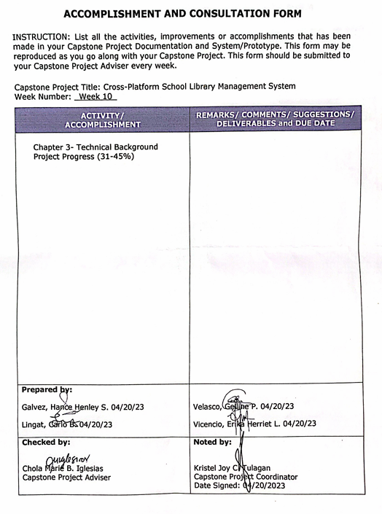

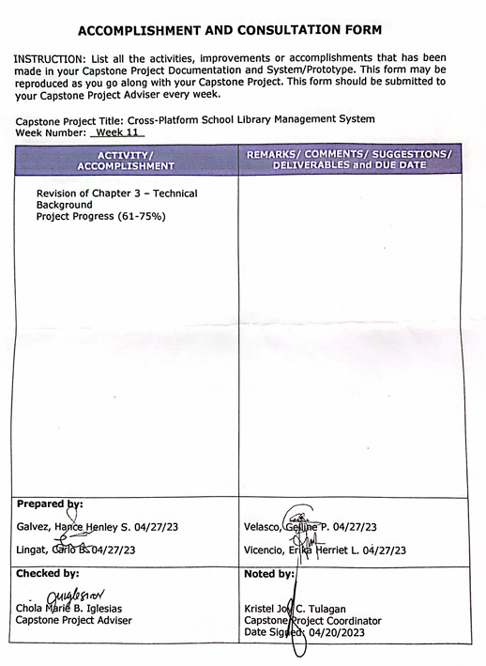

1. Personal Vitae

Curriculum Vitae of



**Hance Henley S. Galvez**

Purok Magsaysay A, Zone 1 KPS Brgy Labangal,

galvez.224297@gensan.sti.edu.ph

0950263166

EDUCATIONAL BACKGROUND

|  |  |  |
| --- | --- | --- |
| Level | Inclusive Dates | Name of school/ Institution |
| Tertiary | 2021 - 2023 | STI College – Gensan, Inc. |
| Senior High School | 2018 - 2019 | GSCNSSAT |
| High School | 2014 - 2017 | GSCNSSAT |
| Elementary | 2008 - 2013 | Dadiangas West Cenral Elementary School |

PROFESSIONAL OR VOLUNTEER EXPERIENCE

|  |  |  |
| --- | --- | --- |
| Inclusive Dates | Nature of Experience/  Job Title | Name and Address of Company or Organization |
| 2022-present | Food Panda Rider | Food Panda |

AFFILIATIONS

|  |  |  |
| --- | --- | --- |
| Inclusive Dates | Name of Organization | Position |
| N/A | N/A | N/A |

SKILLS

|  |  |  |
| --- | --- | --- |
| SKILLS | Level of Competency | Date Acquired |
| Cellphone Repair | Intermediate | 2022 |

TRAININGS, SEMINARS, OR WORKSHOPS ATTENDED

|  |  |
| --- | --- |
| Inclusive Dates | Title of Training, Seminar, or Workshop |

2017-2022 NC II in Electrical Installation and Maintenance

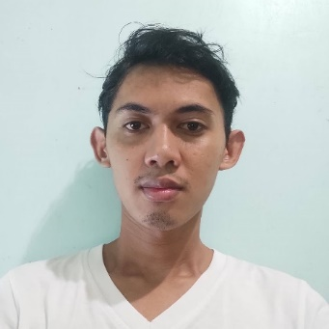 Curriculum Vitae of

Carlo B. Lingat

Ph2, Blk 34, Raja Buayan, Tambler

lingat.222749@gensan.sti.edu.ph

09217382923

EDUCATIONAL BACKGROUND

|  |  |  |
| --- | --- | --- |
| Level | Inclusive Dates | Name of school/ Institution |
| Tertiary | 2021 - 2023 | STI College – Gensan, Inc. |
| Senior High School | 2018 - 2019 | General Santos City National High School |
| High School | 2014 - 2017 | General Santos City National High School |
| Elementary | 2008 - 2013 | Dadiangas West Central Elementary School |

PROFESSIONAL OR VOLUNTEER EXPERIENCE

|  |  |  |
| --- | --- | --- |
| Inclusive Dates | Nature of Experience/  Job Title | Name and Address of Company or Organization |
| N/A | N/A | N/A |

AFFILIATIONS

|  |  |  |  |  |
| --- | --- | --- | --- | --- |
| Inclusive Dates | Name of Organization | | | Position |
| N/A | | N/A | N/A | |

SKILLS

|  |  |  |
| --- | --- | --- |
| SKILLS | Level of Competency | Date Acquired |
| N/A | N/A | N/A |

TRAININGS, SEMINARS, OR WORKSHOPS ATTENDED

|  |  |
| --- | --- |
| Inclusive Dates | Title of Training, Seminar, or Workshop |

|  |  |
| --- | --- |
| 2019-2024 | NC II in Computer Systems Servicing |

 Curriculum Vitae of

Gelline P. Velasco

Uranus Street, Prk. Villanueva, Brgy. Calumpang

velasco.220366@gensan.sti.edu.ph

09050954590

EDUCATIONAL BACKGROUND

|  |  |  |
| --- | --- | --- |
| Level | Inclusive Dates | Name of school/ Institution |
| Tertiary | 2021 - 2023 | STI College – Gensan, Inc. |
| Senior High School | 2018 - 2019 | General Santos City National High School |
| Junior High School | 2014 - 2017 | General Santos City National High School |
| Elementary | 2008 - 2013 | H.N Cahillsot Elementary School |

PROFESSIONAL OR VOLUNTEER EXPERIENCE

|  |  |  |
| --- | --- | --- |
| Inclusive Dates | Nature of Experience/  Job Title | Name and Address of Company or Organization |
| N/A | N/A | N/A |

AFFILIATIONS

|  |  |  |
| --- | --- | --- |
| Inclusive Dates  N/A | Name of Organization  N/A | Position  N/A |

SKILLS

|  |  |  |
| --- | --- | --- |
| SKILLS | Level of Competency | Date Acquired |
| Hardware Troubleshooting | Beginner | 2020 |
| Software Troubleshooting | Beginner | 2020 |

TRAININGS, SEMINARS, OR WORKSHOPS ATTENDED

|  |  |  |
| --- | --- | --- |
| Inclusive Dates | | Title of Training, Seminar, or Workshop |
| 2019-2024 | NC II in Computer Systems Servicing | |

Curriculum Vitae of

Erika Herriet L. Vicencio

19 Capareda St., Brgy. Lagao, General Santos City

Vicencio.220448@gensan.sti.edu.ph

0997-318-1330

EDUCATIONAL BACKGROUND

|  |  |  |
| --- | --- | --- |
| Level | Inclusive Dates | Name of school/ Institution |
| Tertiary | 2021 - 2023 | STI College – Gensan, Inc. |
| Vocational/Technical | 2018 - 2019 | Irineo L. Santiago National High School |
| High School | 2014 - 2017 | Irineo L. Santiago National High School |
| Elementary | 2008 - 2013 | Surallah Central Elementary School |

PROFESSIONAL OR VOLUNTEER EXPERIENCE

|  |  |  |
| --- | --- | --- |
| Inclusive Dates | Nature of Experience/  Job Title | Name and Address of Company or Organization |
| N/A | N/A | N/A |

AFFILIATIONS

|  |  |  |
| --- | --- | --- |
| Inclusive Dates | Name of Organization | Position |
| 2017 - 2019 | Red Cross Youth Metrian | PIO |

SKILLS

|  |  |  |
| --- | --- | --- |
| SKILLS | Level of Competency | Date Acquired |
| N/A | N/A | N/A |

TRAININGS, SEMINARS, OR WORKSHOPS ATTENDED

|  |  |
| --- | --- |
| Inclusive Dates | Title of Training, Seminar, or Workshop |

March 2016 First Aid Training